Kartik Padave

A022

70362019039

Experiment 11

**Aim**

To implement Digital Signature using jwt.io.

**Theory**

A digital signature is a mathematical scheme for verifying the authenticity of digital messages or documents. A valid digital signature, where the prerequisites are satisfied, gives a recipient very high confidence that the message was created by a known sender (authenticity), and that the message was not altered in transit (integrity). Digital signatures are a standard element of most cryptographic protocol suites, and are commonly used for software distribution, financial transactions, contract management software, and in other cases where it is important to detect forgery or tampering.

JSON Web Token (JWT) is an open standard (RFC 7519) that defines a compact and self-contained way for securely transmitting information between parties as a JSON object. This information can be verified and trusted because it is digitally signed. JWTs can be signed using a secret (with the HMAC algorithm) or a public/private key pair using RSA or ECDSA. Although JWTs can be encrypted to also provide secrecy between parties, we will focus on signed tokens. Signed tokens can verify the integrity of the claims contained within it, while encrypted tokens hide those claims from other parties. When tokens are signed using public/private key pairs, the signature also certifies that only the party holding the private key is the one that signed it.

**Steps**

1. Go to website <https://jwt.io/>

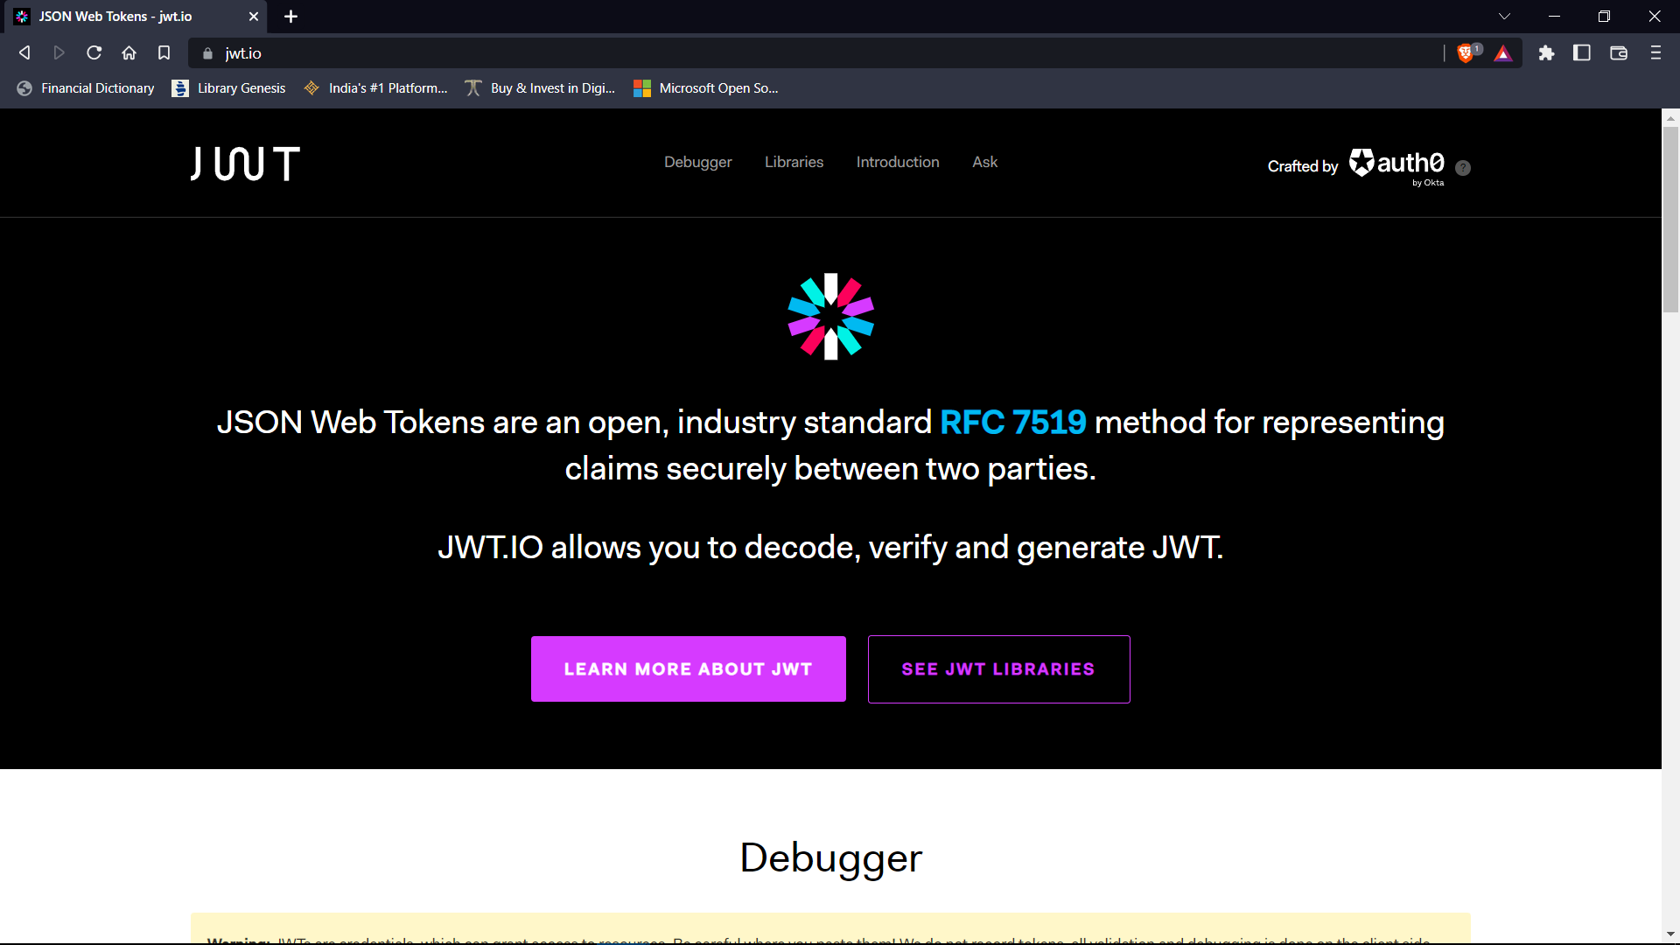

1. Scroll down to debugger and select the algorithm type. Here we have selected HS256.

1. In the payload section of decoded part change name from “John Doe” to your name. Here, “Kartik Padave”.

1. Now copy the JSON token from Encoded part. Refresh the page and paste the copied JSON token in the encoded part. Now if you check the decoded will give your name in the decoded part.

**Conclusion**

Hence, we were able to create Digital Signature using JWT.io.